**Coursera IBM Capstone Project**

*Detecting the best waterfall spots in Tamilnadu to set up a restaurant*

**Gokulakannan S**

11th June 2020

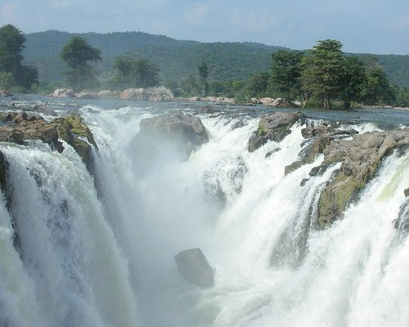

**Introduction**

Tamilnadu is one of the 2 states in India and has 28 beautiful waterfalls across the state. The waterfalls being very beautiful have resulted in sufficient increase of the revenue of the state. Lots of tourists visit the waterfalls during the weekends and vacations in order to relax themselves. Waterfalls are the best spots for vacations. Tamilnadu being a state with 28 waterfalls welcomes tourists from all over the world to spend their leisure time here. The travel agencies try their best to find the best amenities and attract the tourists with offers. New startups and hotel business caterers also find opportunities to start their business or expand their business at these tourist spots.

**Situation**

The tourists find it difficult to find a proper outlet for having meals. Hence, the project aims in finding the best waterfalls spot to set up a restaurant to meet the needs of tourists.

**Interest**

This might help the tourists in spending a comfortable vacation or weekend without any hustle or challenge in finding a decent meal outlet nearby. This also helps new startups to open its outlet in the vicinity of these waterfalls or renowned restaurants to open their branches here.

**Data Sources**

The data regarding the names of the waterfalls has been taken from the Wikipedia website listed [here](https://en.wikipedia.org/wiki/Category:Waterfalls_of_Tamil_Nadu). The data lacks the exact location of the waterfalls as well as the venues nearby. Hence these datas are acquired from the [Geocoder Package](https://pypi.org/project/geocoder/) in Python. The nearby venues are found using the [Foursquare API](https://foursquare.com/). The extractions and cleaning will be discussed further.